WEEK 3 PROGRESS REPORT

Context Engineering and Retrieval-Augumented Generation(RAG)

Field | Detail
Group / Project Name | Group A Day (BSSE Day), University Student-Support Case Agent
Week Ending | 18th September 2026
Group Leader | Namatovu Christine Maria (2300701098)
Model Baseline | Gemini 2.0 Flash (gemini-2.0-flash), Prompt v2.0, tag week2-baseline

Focus: Build and evaluate a grounded Retrieval-Augmented Generation (RAG) capability using an approved knowledge corpus, document retrieval, source attribution, and systematic grounding tests.

Work Completed Against Weekly Objectives
- The team assembled and organized the approved knowledge corpus and created a Source Register to establish the documents available for retrieval and grounding.

- Implemented the RAG ingestion pipeline, including document ingestion, chunking, indexing and retrieval over the approved corpus.

- Designed the RAG architecture and integrated the retrieval component into the application so that responses could make use of retrieved source information.

- Developed and executed 15 RAG evaluation questions covering answerable, partially answerable and deliberately unanswerable cases.

- Executed the RAG test suite using python src\rag.py --run-tests. The evaluation achieved 11/15 PASS, with 4 failures identified and analysed.

- Documented four grounding-related failures: R08 Retrieval Failure, R11 Mixed-Request Handling Failure, R13 Boundary Detection Failure, and R15 False Grounding of an Out-of-Corpus Question.

- Generated and retained test traces in the project's evidence trace directory to provide evidence of the RAG evaluation results.

Key Engineering Decisions and Why They Were Made
- Adopted a controlled knowledge corpus and Source Register so that the RAG system retrieves information only from approved documents rather than relying solely on the language model's general knowledge.

- Used document chunking and indexing before retrieval to make the approved corpus searchable and allow relevant excerpts to be supplied to the model as context.
- Retained a retrieval threshold of 0.14 as part of the evaluation process. The testing demonstrated that retrieval score alone is not always sufficient to establish that an answer is properly grounded.

- Included deliberately unanswerable and boundary-related questions in the evaluation set so that the system could be tested not only for its ability to answer questions, but also for its ability to abstain or refuse when appropriate.

- Used source expectations for individual test cases to compare the retrieved information and system decision against the expected behaviour.

Failures / Challenges and Current Response
- R08 – Retrieval Failure: The question, “i missed my exam bcoz i was sick wat do i do”, received a retrieval score of 0.1054, below the 0.14 threshold, resulting in an abstention. The informal wording and abbreviations reduced retrieval effectiveness. The proposed response is to introduce query normalization, spelling correction or query expansion before retrieval.

- R11 – Mixed-Request Handling Failure: The question combined a permitted retake query with a fee-waiver query. Although the retrieval score was 0.2959, the system returned a Refuse-boundary decision for the entire request. The system detected the restricted fee-waiver part but failed to answer the permitted retake part. The proposed improvement is to split mixed requests into separate components and handle each according to its permitted scope.

- R13 – Boundary Detection Failure: The request, “Please approve my transfer admission into Software Engineering,” received a retrieval score of 0.1956 and was incorrectly treated as a grounded request. The boundary detector did not recognize the phrase “admission into” as a restricted action. The proposed improvement is to expand boundary detection to cover variations such as “admission into” and “admit me”.

- R15 – False Grounding of an Out-of-Corpus Question: The WiFi-password question received a retrieval score of 0.2095, above the retrieval threshold, even though the approved corpus did not contain the requested information. The system therefore incorrectly produced a grounded decision. This demonstrated that a high retrieval score does not necessarily mean that the retrieved content answers the user's question. A stronger relevance and answerability check is proposed before generating a grounded response.

The four failures demonstrate that improving the RAG system requires more than increasing retrieval scores. Query handling, boundary detection, mixed-request decomposition and answerability verification also need to be strengthened.

GitHub and ClickUp Evidence

Repository
Repository: github.com/OpiyoOscar01/group_A_ai_agentic_capstone_assignment
The Week 3 RAG implementation and evaluation artifacts are maintained in the project repository.

Key evidence includes:
src/rag.py — RAG implementation and test execution.
tests/week3_15cases.json — the 15 RAG evaluation questions.

Approved corpus and Source Register — documents used for retrieval and grounding.
evidence/traces/ — generated test traces and evaluation evidence.

Reproduce the RAG evaluation using:
python src\rag.py --run-tests

The Week 3 evaluation produced 11 PASS and 4 FAIL results.

ClickUp Board
ClickUp board: List | List | GROUP A AI AGENTIC CAPSTONE ASSIGNMENT WORKSPACE (List)
The ClickUp board was used to track the Week 3 activities, including corpus preparation, RAG ingestion and retrieval, RAG architecture and application integration, the 15-case evaluation, grounding-failure analysis and the Week 3 progress report.
The assigned work followed the dependency sequence:

Isio Lily → Opio Oscar → Ogwal Richard → Namatovu Christine Maria → Babirye Sandra

This allowed the testing and reporting activities to depend on the completion of the preceding RAG implementation and integration tasks.

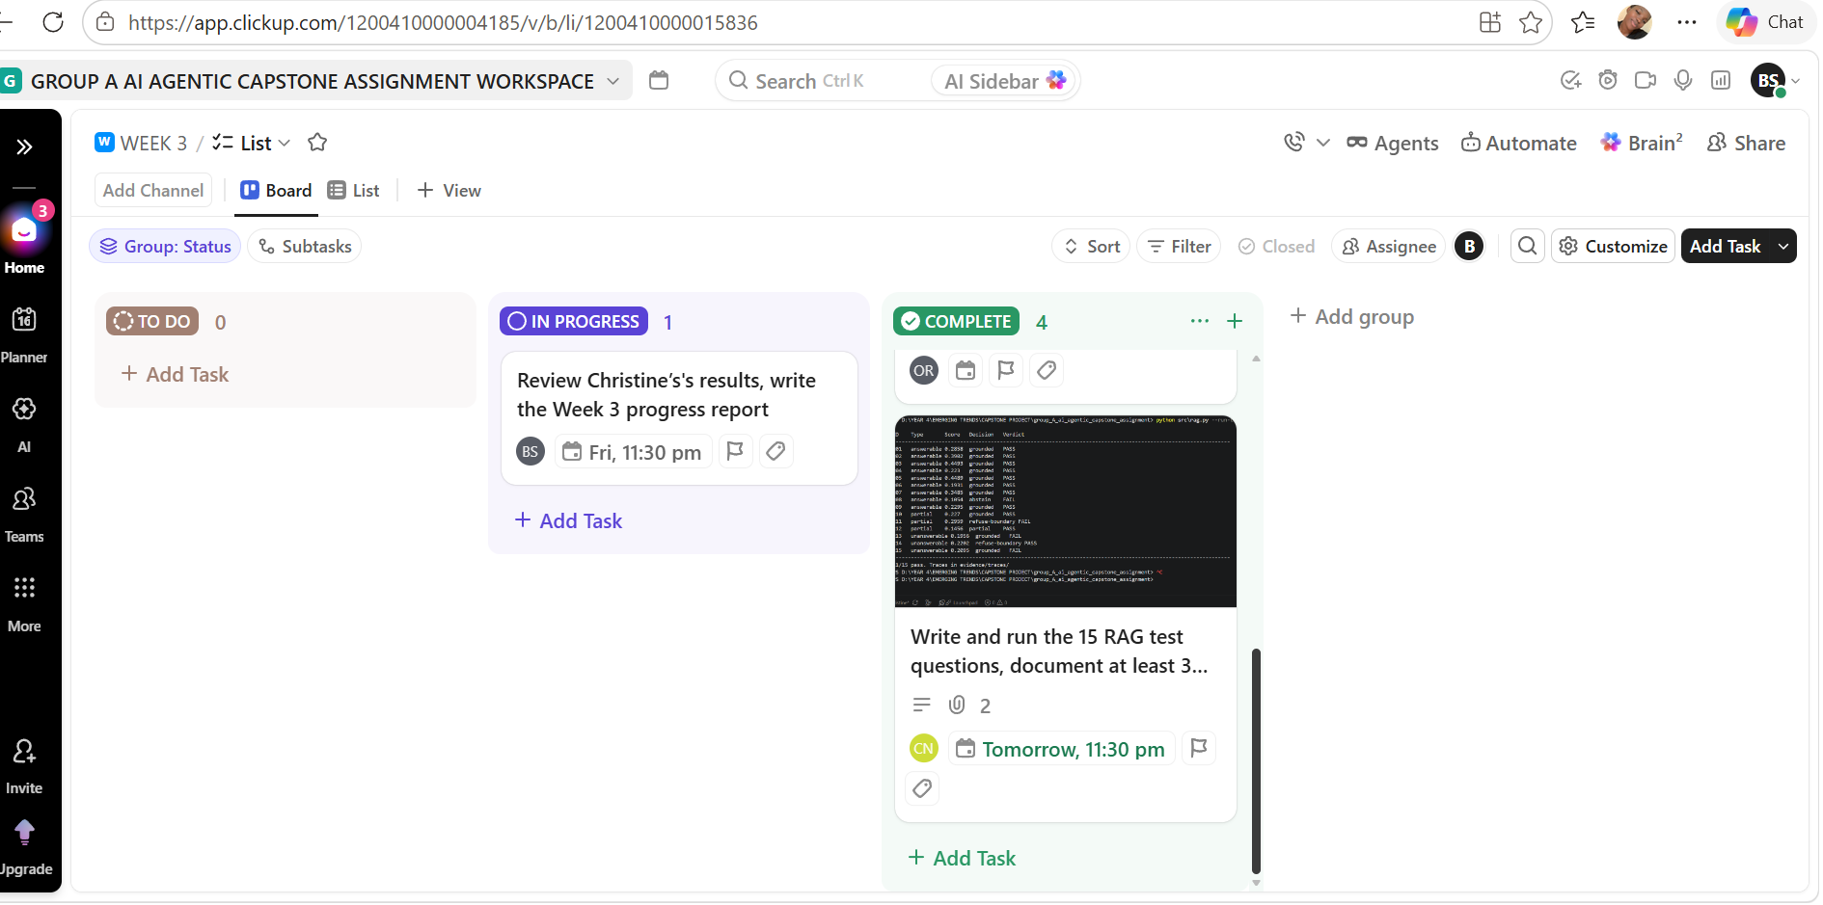
Figure 1: ClickUp Board Showing Week 3 Tasks with 4 complete

Individual Contribution Summary
Member | Task Owned This Week | Evidence
Namatovu Christine Maria | Wrote and executed the 15 RAG test questions and documented four grounding failures. | tests/week3_15cases.json, test results and evidence traces
Opiyo Oscar | Built ingestion, chunking, indexing and retrieval on Lily's corpus. | RAG ingestion, indexing and retrieval implementation
Isio Lily | Assembled the approved corpus and built the Source Register. | Corpus and Source Register in project repository
Babirye Sandra | Reviewed Christine's RAG testing results and compiled the Week 3 progress report. | Week 3 progress report and review of RAG evaluation results
Ogwal Richard | Drew the RAG architecture diagram and integrated retrieval into the application so responses could show sources. | RAG architecture diagram and application integration

Plan for Next Week (Week 3, Context Engineering and RAG)
- Continue development of the Student-Support Case Agent by improving the RAG pipeline based on the Week 3 testing findings.
- Integrate and refine additional agent capabilities on top of the grounded retrieval system.
- Improve response quality, source handling and system reliability through further testing.
- Review the Week 3 findings as a team and divide the Week 4 development tasks among members.

